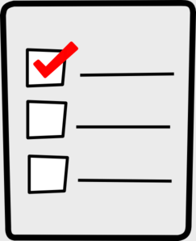
Weekly Checklist
Week of: April 6th

Required Assignments | Required Assignments
Math:  - Video for 12.3  - 12.3 Homework (regular OR Challenge)  - Video for 12.4  - 12.4 Homework (regular OR Challenge  Science:  - Review Video for pages 6-13  - Video for pages 14-17  - Questions for pages 14-17 | Reading:  - Journal prompts  - Good Morning Sunshine  - Text Structure Video  - Text Structure quiz  - Freckle assignment  - Epic assignment  - Khan Academy assignment  - Prepositional Phrase quiz  Social Studies:  - Midwest people video  - Questions about the video

